Medieval churches architecture
  - medieval churches
There is 2 types of churches
Gothic churches
Romanesque churches

gothic churches
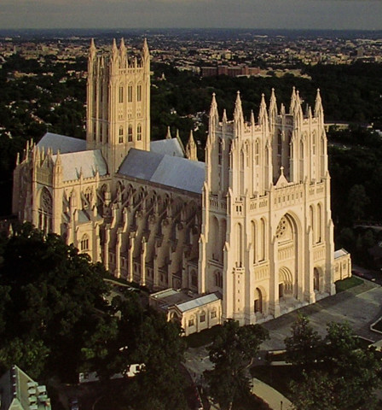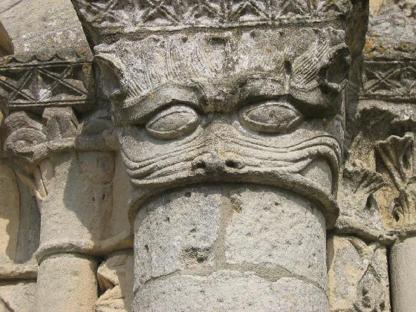
they had pointy arches ,staned glass windows,gargoyles and flying buttresses. The first man to build a gothic church was a french man.he put arches on the outside to hold up the roof.they ar called flying buttresses.gothic cathedrals often have spires coming out of them.they have thinner walls than romanesque.there is a famous gothic church in france called bourges cathedral.there is more gothic churches tan there would be romanesque

romanesque

these churches have roundy arches,small windows and beautiful decorations.it was around 1000 ad that christians started building romenesque churches.they were the 1st churches built in stone.they had roundy arches and small windows.they were dark and gloomy in side.the was held up with heavy round columns and thick walls.thats why they had small windows.